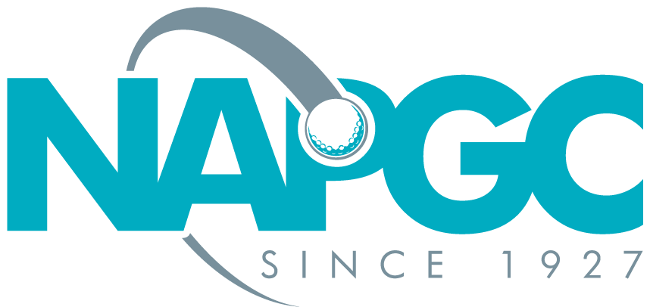
MARY FORSTER BOWL 2023-2024
RESULT SHEET – GROUP…...
…………………………………………….
Les Hasell
Competition Organiser
6 Chepstow Close
Pound Hill, Crawley RH10 7XF
01293-884537/07788-518183
Les.Hasell@napgc.org.uk

Played at: |  | Date:
Team Name:  Club: | Captains Signature
 |  | Playing H/C | Points |  | Total
Player 1
Player 2
Player 3
Team Name:  Club: | Captains Signature
Player 1
Player 2
Player 3
Team Name:  Club: | Captains Signature
Player 1
Player 2
Player 3
Team Name:  Club: | Captains Signature
Player 1
Player 2
Player 3

