NAPGC Ballantyne Trophy 2024 Result Sheet

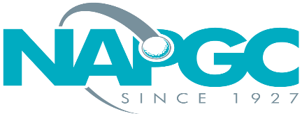 | Date of match:
 | Club/team:
 | v Club/team:

Result of match:

Fourball better ball match play team knockout. Maximum individual handicap index is 20.0 Each player shall establish their individual rounded course handicap. The lowest player in each group will then play off zero, with other players receiving 90% of the difference in course handicaps rounded to a whole number. All strokes to be taken as per the stroke index table.

*Each pair shall be awarded 1 point for a win 0.5 for a tie. In the event of the overall result being all square, the first tied match shall play a sudden death play-off.

 | Home Club: |  |  |  |  | Away Club:
 | Name of Players | H’cap Index | Cse H’cap | Shots | Result | Name of Players | H’cap Index | Cse H’cap | Shots | Result
1
2
3
 | Points: |  |  |  |  | Points:

Winner to email/text result on the night of the match to Anne Butcher:
anne.butcher@napgc.org.uk 07715 760247

Full result sheet to then be electronically returned within 48 hours

Teams can send details a picture or scanned copy of the result sheet.
Or simply record the result in an email. If doing this the overall result should be stated and names of all players (both teams) listed in the email.

