NAPGC Men’s Top Rock Salver 2024 Result Sheet

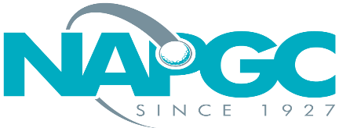 | Date of match:
 | Club/team:
 | v Club/team:

Result of match:

Fourball better ball match play knockout. Maximum individual handicap index is 24.0 Each player shall establish their individual rounded course handicap. The lowest player will play off zero, with other players receiving 90% of the difference in course handicaps rounded to a whole number. All strokes to be taken as per the stroke index table.

 | Home Club: |  |  |  |  | Away Club:
 | Name of Players | H’cap Index | Cse H’cap | Shots | Result | Name of Players | H’cap Index | Cse H’cap | Shots | Result
1
 | Points: |  |  |  |  | Points:

Winner to email/text result on the night of the match to Deryck Walker:
deryck.walker@napgc.org.uk 07767 2477303

Full result sheet to then be electronically returned within 48 hours

Teams can send details a picture or scanned copy of the result sheet.
Or simply record the result in an email. If doing this the overall result should be stated and names of all players (both teams) listed in the email.

