NAPGC Women’s Top Rock Bowl 2024 Result Sheet

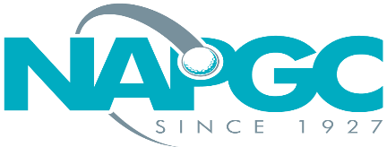 | Date of match:
 | Club/team:
 | v Club/team:

Result of match:

Greensomes match play knockout. Maximum individual handicap index is 36.0

Playing handicaps shall be calculated as; unrounded lower course handicap x 0.6, plus the unrounded higher course handicap x 0.4. After adding the unrounded figures, the aggregate figure is rounded to provide the playing handicap. The pair with the lowest playing handicap shall concede the full difference in handicaps to the other pair.

Home Club
 | Names of Players |  | Handicap Index | Cse H’cap  (unrounded) | Cse H’cap x 60% of lower 40% of higher | Agg of 60%+40% figures.  Round for playing h’cap | Result
1

Away Club
 | Names of Players |  | Handicap Index | Cse H’cap  (unrounded) | Cse H’cap x 60% of lower 40% of higher | Agg of 60%+40% figures.  Round for playing h’cap | Result
1

Winner to email/text result on the night of the match to Deryck Walker:
deryck.walker@napgc.org.uk 07767 2477303

Full result sheet to then be electronically returned within 48 hours

Teams can send details a picture or scanned copy of the result sheet.
Or simply record the result in an email. If doing this the overall result should be stated and names of all players (both teams) listed in the email.

